**input-1**

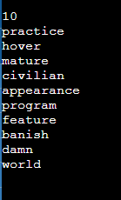

**input-2**

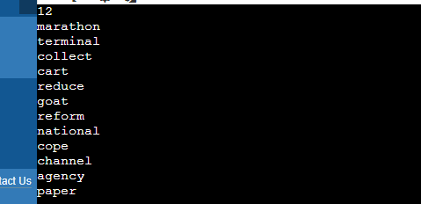

**22**

**practice**

**hover**

**mature**

**civilian**

**appearance**

**program**

**feature**

**banish**

**damn**

**world**

**marathon**

**terminal**

**collect**

**cart**

**reduce**

**goat**

**reform**

**national**

**cope**

**channel**

**agency**

**paper**

**10**

**practice**

**hover**

**mature**

**civilian**

**appearance**

**program**

**feature**

**banish**

**damn**

**world**